Takeda Column/ Bar Chart Visualization.
- High level requirements summary
To create within the High Charts map library software, Column/ Bar Chart as a visualization layer. that using the Existing common component in our storybook. We already have an existing common component; it isn’t complete nor is it configurable. The goal is to use and build the remaining elements/requirements into it.

User configuration screen/tile name: Column/ Bar Chart

Requirements description

Existing common component in our storybook. We already have an existing common component; it isn’t complete nor is it configurable. The goal is to use and build the remaining elements/requirements into it.

User configuration screen/tile name: Column/ Bar Chart

Image 1: Column Chart – vertical representation of data

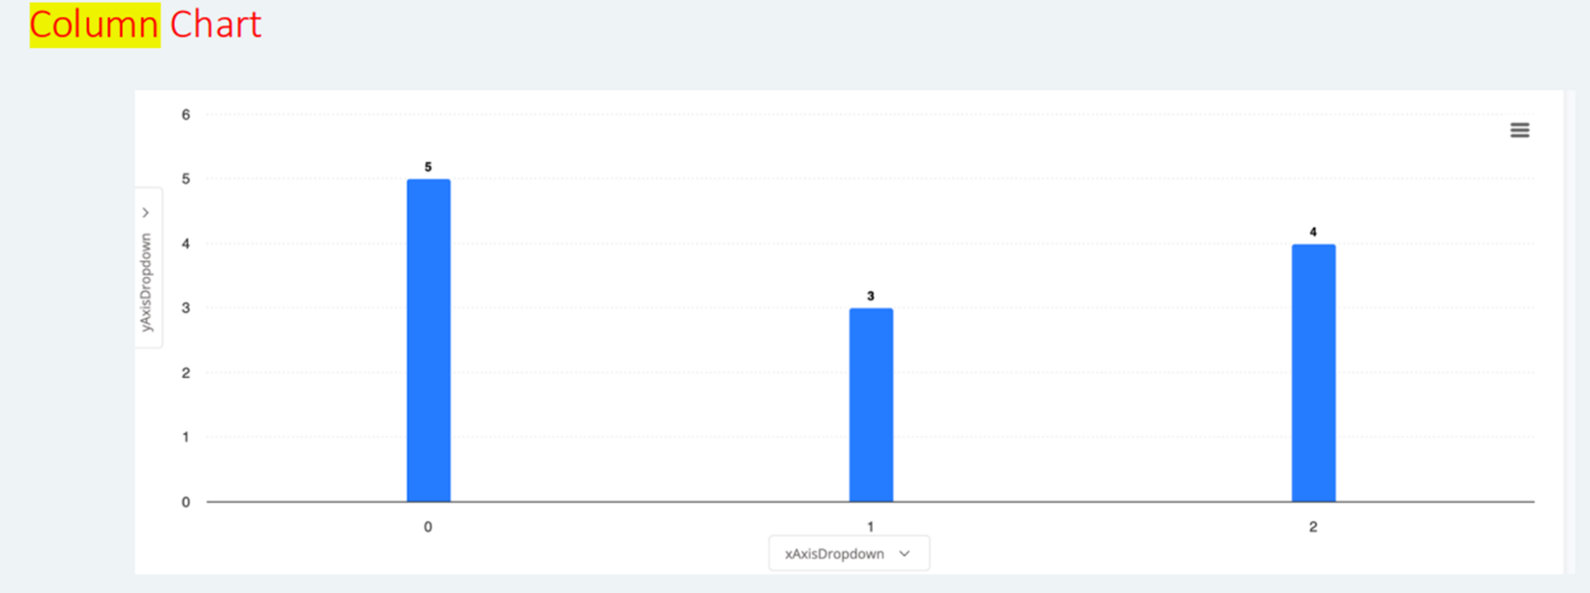

Image 2: Vertical Bars
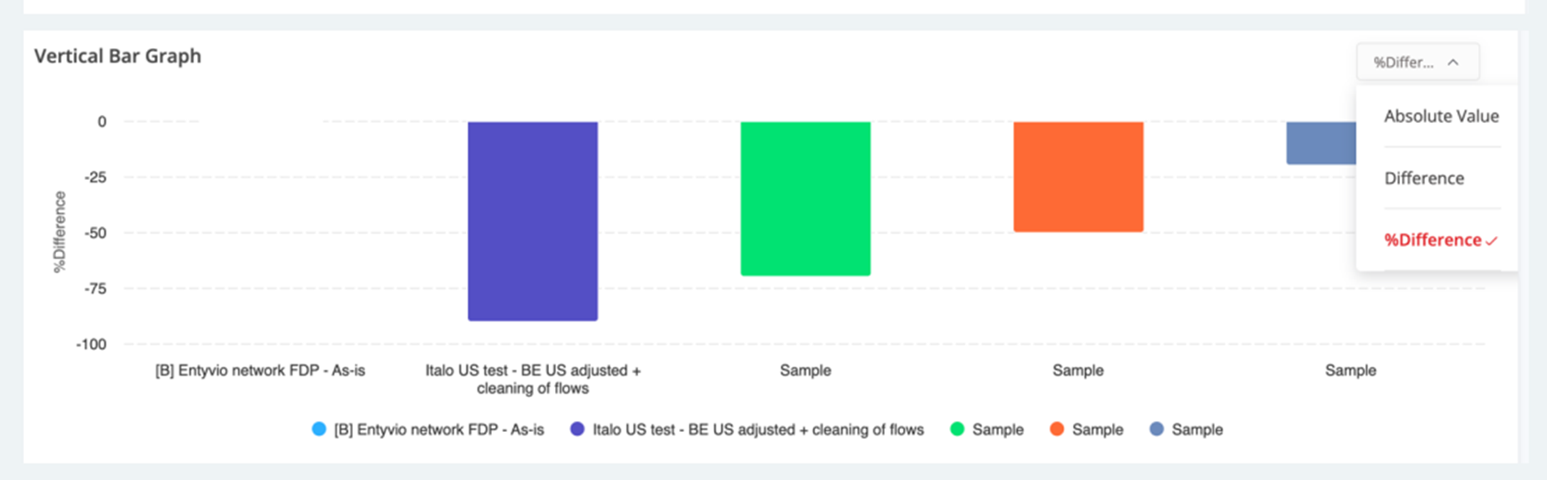

Image: 3
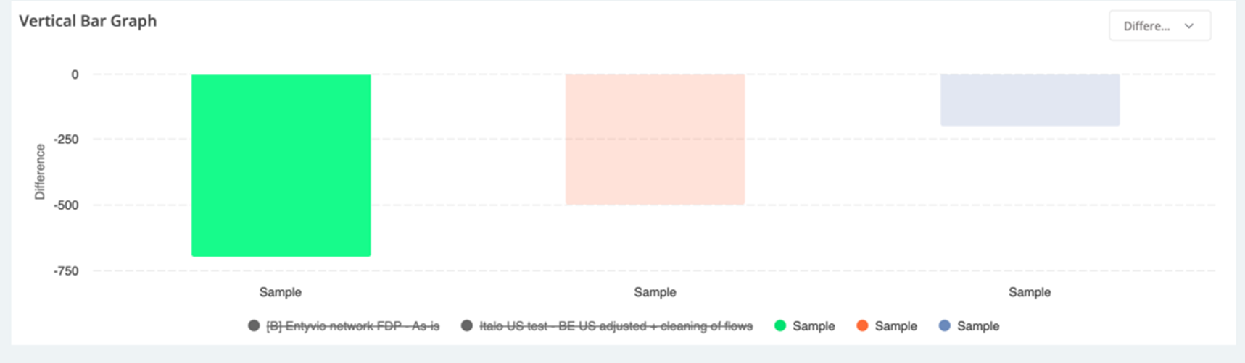

Image 4: Bar Chart
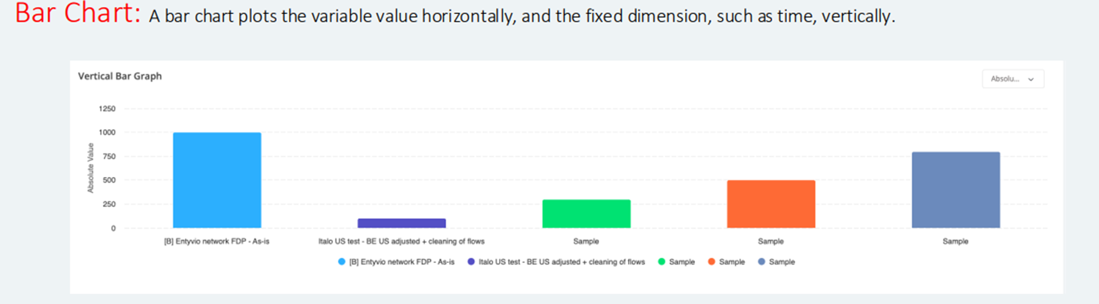

Requirements:  DAD-1346 - https://onetakeda.atlassian.net/browse/BICN-86029  Column Chart Configuration:  A column chart is where data is compared in vertical bars. Each bar represents a category of data, and the height of the bar corresponds to the value of the category.  - Req#1 - Column Chart tile name  - Req#2 - Tile’s size  - Req#3 - X-Axis Data Field  - Req#4 -Linear grouping (sequencing of data in numerical or an ordered sequence which can result in something increasing or decreasing) OR  - Req#5 - Categorical grouping (categorical grouping of data on distinct categories, example: product types / departments/ countries/gender)  - Req#6 - Y-Axis Data Field  - Req#7 - Configure auto-scaling (automatically adjustment of the scale) or set min/max  - Req#7 - Select colour palette  - Req#8 - Provide option to select secondary field to further differentiate bar segments  - Req#9 - Allow user to specify aggregation function (sum, average, count etc.)  - Req#10 - Offer filter, sort, search options  - Req#11 - Tooltips and drilldowns  - Req#12 - Vertical (toggle up and down or show/hide or on/off)  - Req#13 - Horizontal Toggle (a switch between 2 or more states – left/right) or default toggle to one option  Bar Chart Configurations  This is a type of graph that uses horizontal bars to compare different categories of data -bars go sideways instead of up and down.  - Req#1 - Column Chart tile name  - Req#2 - Tile’s size  - Req#3 - X-Axis Data Field  - Req#4 -Linear grouping (sequencing of data in numerical or an ordered sequence which can result in something increasing or decreasing) OR  - Req#5 - Categorical grouping (categorical grouping group data on distinct categories, example: product types / departments/ countries/gender)  - Req#6 - Y-Axis Data Field  - Req#7 - Configure auto-scaling (automatically adjustment of the scale) or set min/max  - Req#7 - Select colour palette  - Req#8 - Provide option to select secondary field to further differentiate bar segments  - Req#9 - Allow user to specify aggregation function (sum, average, count etc...)  - Req#10 - Offer filter, sort, search options  - Req#11 - Tooltips and drilldowns  - Req#12 - Vertical (toggle up and down or show/hide or on/off)  - Req#13 - Horizontal Toggle (a switch between 2 or more states – left/right) or default toggle to one option  Storybook  Old version of Bar Chart in Storybook - Can most likely be deleted (please do so after this is assessed)  Current version of Bar Chart in storybook - would be nice to consolidate with the below so a toggle can take you from one to the other  Stacked version of Bar Chart in storybook  FIGMAS  QSM Implementation  https://www.figma.com/design/WDFoiaEDZljzyFav3zWFZE/AOS---QSM-VD?node-id=18566-21976&t=CQ9MpbhaXHv0dDeS-1  Test Board Implementation  https://www.figma.com/design/0YXXxTj1SyNJKQbWhEGqAx/Test---QC-Board?node-id=7246-42162&t=4pLIk9hZjxFRHE5N-1  Bar chart in Design system, it is below: r  https://www.figma.com/design/5BFYOgkh14TTqgXnNIeB7d/Design-Library_Insight-Center?m=auto&node-id=6862-16355&t=4UNKGK4EozNv5R2q-1  Meeting Victor 23.07.2025  column / bar chart - REMOVE GENERIC COLUMN BAR CHART VERSION concentrate on STACK AND BASIC VERSION  Most important feature of Column Bar Chart - the ability to toggle - consolidate into one chart for column/ bar  Louis - Technical direction – all maps must fall under generic chart in storybook  View the number of entities  Modify the number of tiles on side menu  Paginate tiles to view different information on follow on pages | Chart Type  - Clustered Column / Bar: Groups bars/columns side by side for each category.  - Stacked Column / Bar: Stacks values in each category on top of each other.  - 100% Stacked Column / Bar: Stacks values showing percentages totalling 100%.  - 3D Versions: Adds 3D visual perspective to the same chart types.  Chart Elements  - Chart Title: Main title displayed on top of the chart.  - Axis Titles: Labels that describe each axis.  - Legend: Shows what each colour or pattern in the chart represents.  - Data Labels: Display exact values on each bar/column.  - Gridlines: Horizontal/vertical lines to improve readability.  - Data Table: Shows underlying data in a table below the chart.  - Trendlines: Adds a line representing trends or forecasts.  - Error Bars: Show variability or uncertainty in the data.  Axes Configuration  Horizontal (Category) Axis:  - Axis type: Defines if axis treats entries as text, dates, or auto-detects.  - Position axis: Places axis on tick marks or between them.  - Labels position: Controls where category names are shown.  - Number format: Sets how axis numbers/text are formatted.  - Label interval: Controls how frequently axis labels appear.  Vertical (Value) Axis:  - Minimum/Maximum bounds: Sets the scale range.  - Major/Minor units: Distance between ticks.  - Display units: Shrinks values (e.g., showing 1M instead of 1,000,000).  - Logarithmic scale: Changes scale to logarithmic for wide-ranging values.  - Tick marks: Customize tick mark placement.  - Crosses at: Defines where the axis intersects the other axis.  Data Series Options  - Series overlap: Controls how much bars/columns overlap (0% = side-by-side).  - Gap width: Adjusts spacing between groups (higher = more space).  - Plot on secondary axis: Adds second Y-axis for dual-scale data.  - Invert if negative: Changes fill colour/style for negative values.  - Fill and border: Customize colour, style of bars/columns.  - 3D Format: Adds depth, rotation, and bevel effects in 3D charts.  Legend Options  - Position: Where the legend appears (top, bottom, etc.).  - Overlay: Whether the legend overlaps with the chart.  - Font/Style: Appearance of the legend text and background.  Data Labels  - Label content: Choose what is displayed (value, name, percent, etc.).  - Position: Where the label is placed relative to the bar/column.  - Number format: How label numbers appear (%, currency, decimals).  - Leader lines: Lines connecting label to its bar/column (useful for clarity).  - Separator: Defines how multiple label elements are split (comma, new line).  Miscellaneous  - Switch Row/Column: Reverses which data is treated as categories or series.  - Chart Filters: Temporarily hide or show series/categories.  - Add Secondary Axis: Enables different scales for different series.  Nice to Haves:  Gridlines (Not critical but nice to have)  - Major/Minor gridlines: Main and finer grid lines.  - Style: Customize color, line width, dash type, etc.  Chart Area & Plot Area (Not critical but nice to have)  - Fill: Background color or pattern for entire chart or just plot area.  - Border: Outline around chart or plot area.  - Effects: Shadow, glow, and soft edges for visual styling.  - 3D Rotation: Controls camera angle and depth for 3D charts.  Title Options (Not critical but nice to have)  - Text: Custom title for the chart or axes.  - Position: Where the title is placed.  - Font/Style: Customize appearance

